Communication Through Gesture

### **ASSISTED BY:**

Anil Kumar

Swati Rao

Lalitha Gayathri

**BONAFIED WORK DONE BY:**

Mudundi Siri

Anju Kanumuri

Bala Vegesna

Communication Through Gesture

### Introduction:

This AI and Deep learning course offers practical and task-oriented training using Tensor Flow and keras on Python platform. Recent developments in Deep learning have been nothing short of a revolution and have enabled some of the most exciting and powerful applications in the field of Artificial Intelligence.

This is a specialization course and Deep Learning domain, with one of the most sought-after skills. We will learn the foundations, understand how to build neural networks, learn how to build successful Deep Learning based AI projects using Tensor Flow and Keras. We will work on case studies on computer vision, text data processing, Image processing, Speech analytics - Speech to text / Voice tonality.

We used Python because Python programs can be close to pseudo-code. It is designed to read. Python is reasonably efficient; this will result in much less programming and more efficient code than writing everything in a low-level language

So basically we are using Convolution Neural Network (CNN) process in our project. CNN is a specific type of artificial neural network that uses perceptions, a machine learning unit algorithm, for supervised learning, to analyze data. CNN supply to image processing, natural language processing and other kinds of cognitive tasks.

Objectives of Research:

COMMUNICATION THROUGH GESTURE, Here in this research we focused mainly on the action given by the user to communicate with the machine, also it helps the dumb people to develop in the society.

## Problem Statement:

##### Gestures are a common, integral part of communication. Here, we investigate the roles of gesture and speech in explanations, both for communicators and recipients. Communicators explained how to assemble a simple object, using either speech with gestures or gestures alone. Gestures used for explaining included pointing and exhibiting to indicate parts, action models to demonstrate assembly, and gestures used to convey narrative structure. Communicators using gestures alone learned assembly better, making fewer assembly errors than those communicating via speech with gestures. Recipients understood and learned better from gesture only instructions than from speech-only instructions. Gestures demonstrating action were particularly crucial, suggesting that superiority of gestures to speech may reside, at least in part, in compatibility between gesture and action.

### Review of literature:

##### To many, nonverbal communication may take a back seat to verbal communication. It is often overlooked and may be deemed unimportant. However, this aspect of communication speaks volumes. Nonverbal communication may consist of looking, smiling, frowning, touching, or expressions of surprise

It is important to consider who the more effective communicator is so that we can learn from each other on how to communicate better

### Data Collection:

##### The dataset comprising of different types of hand symbols.

### Methodology:

##### Methods of expressive communication include speaking, signing, gesturing, pointing, or crying. Receptive communication refers to the way in which someone interprets or understands a sender's communication. ... Symbolic communicationrefers to communication that involves a shared message between the sender and the receiver.

##### 5 methods of communication are; Verbal, **Non**-verbal, Written, Oral, Face to face. 5 means of communication are; Internet, Radio, Newspaper, Telephone, Television

##### 

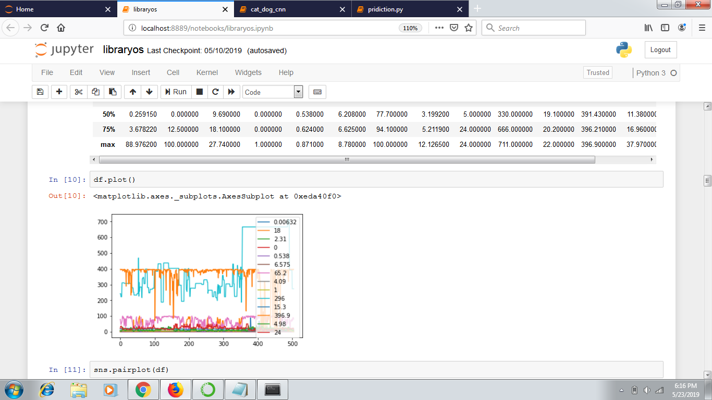

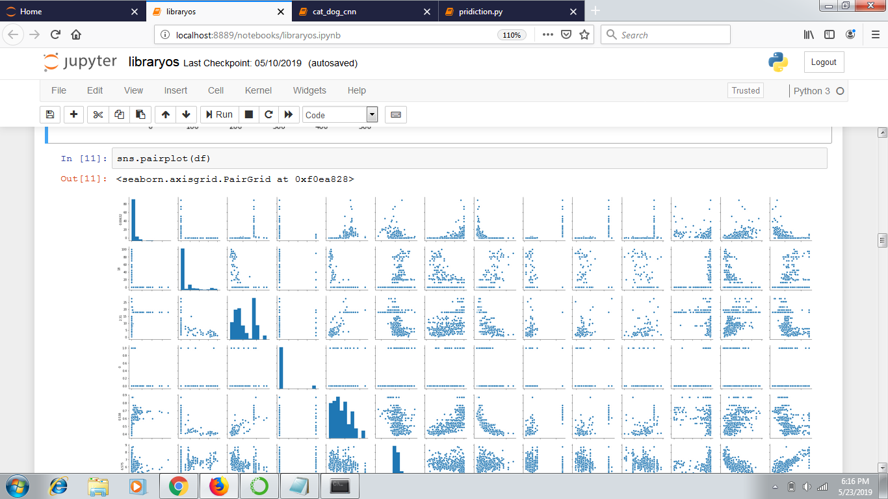

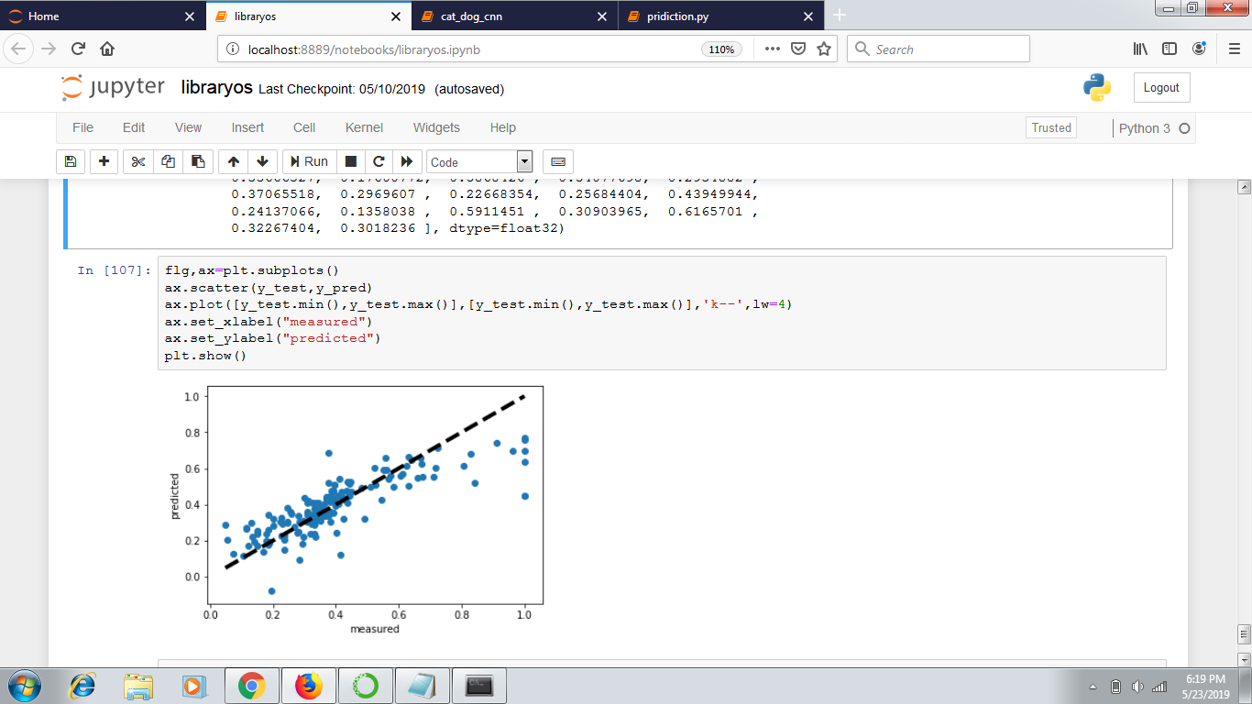

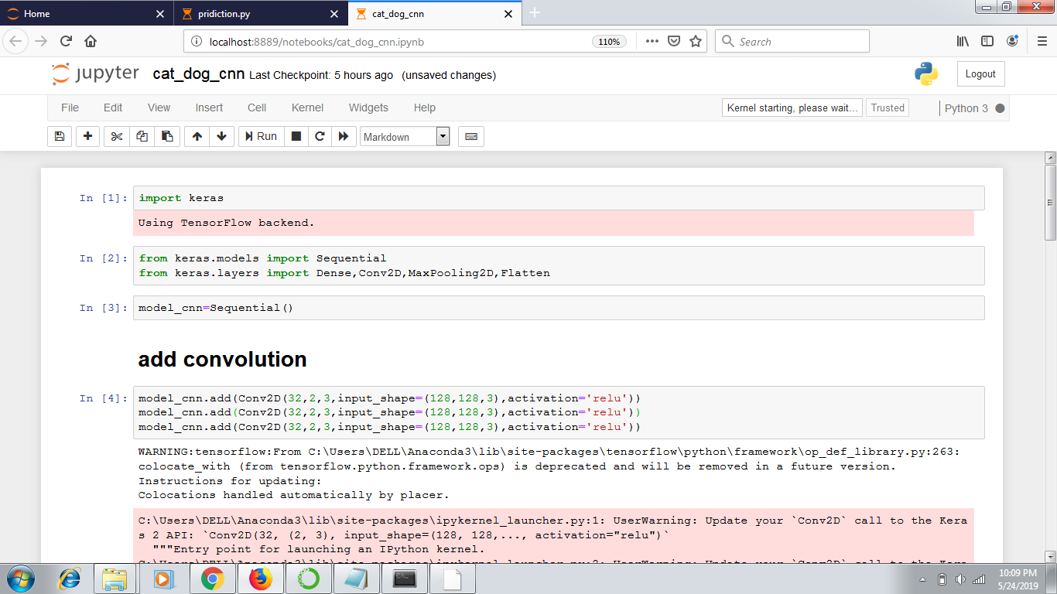

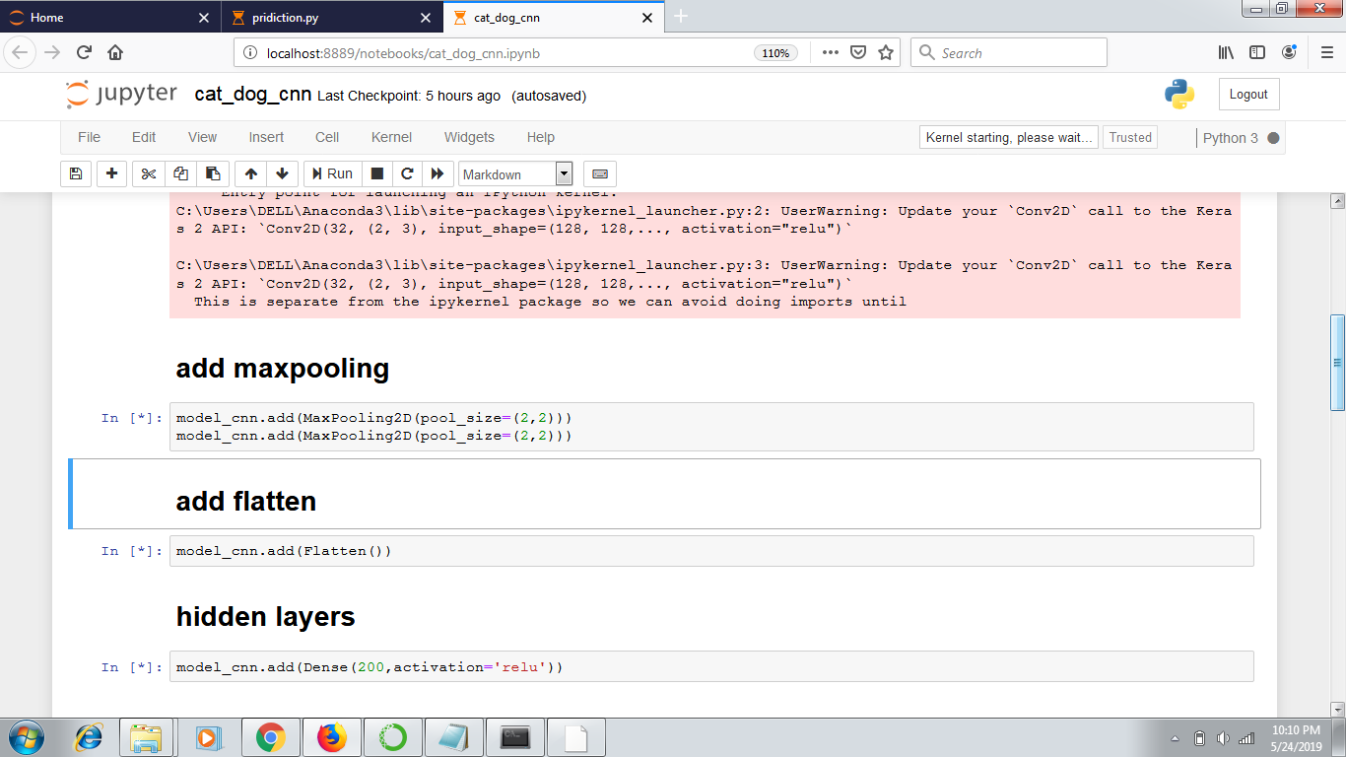

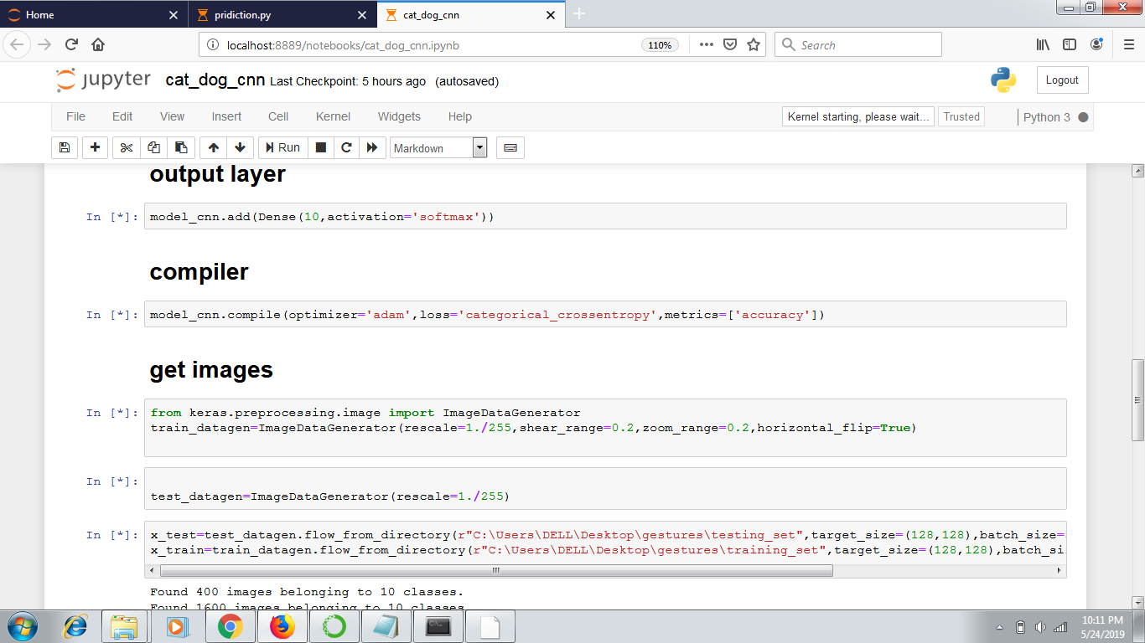

### Prediction

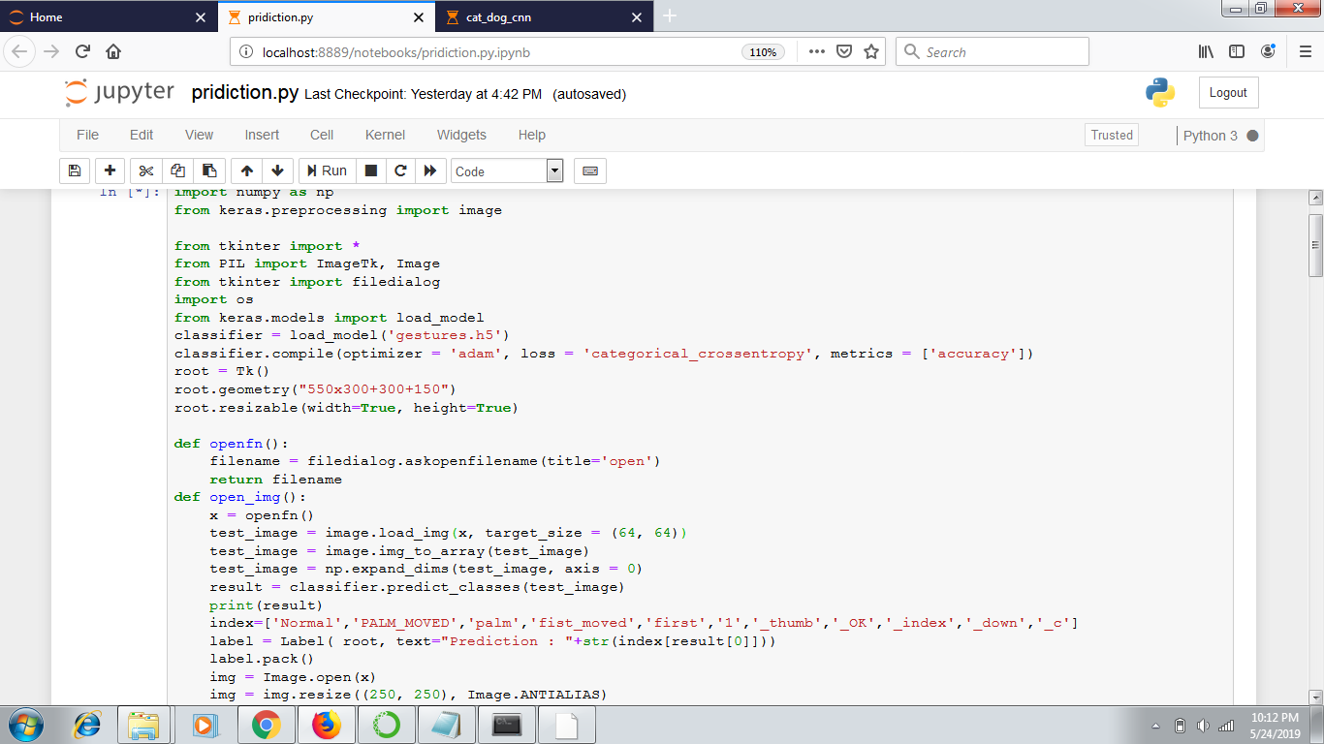

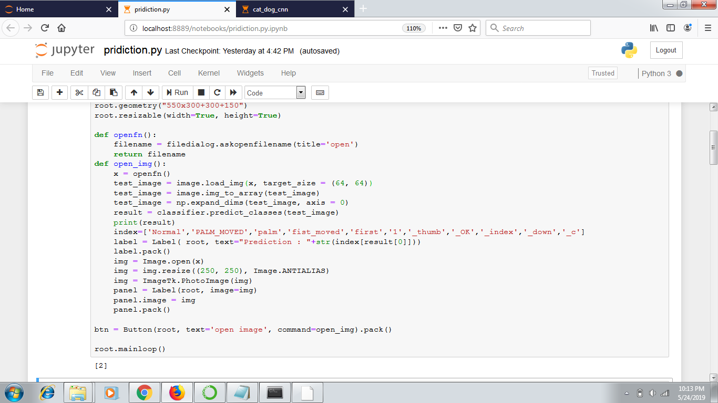

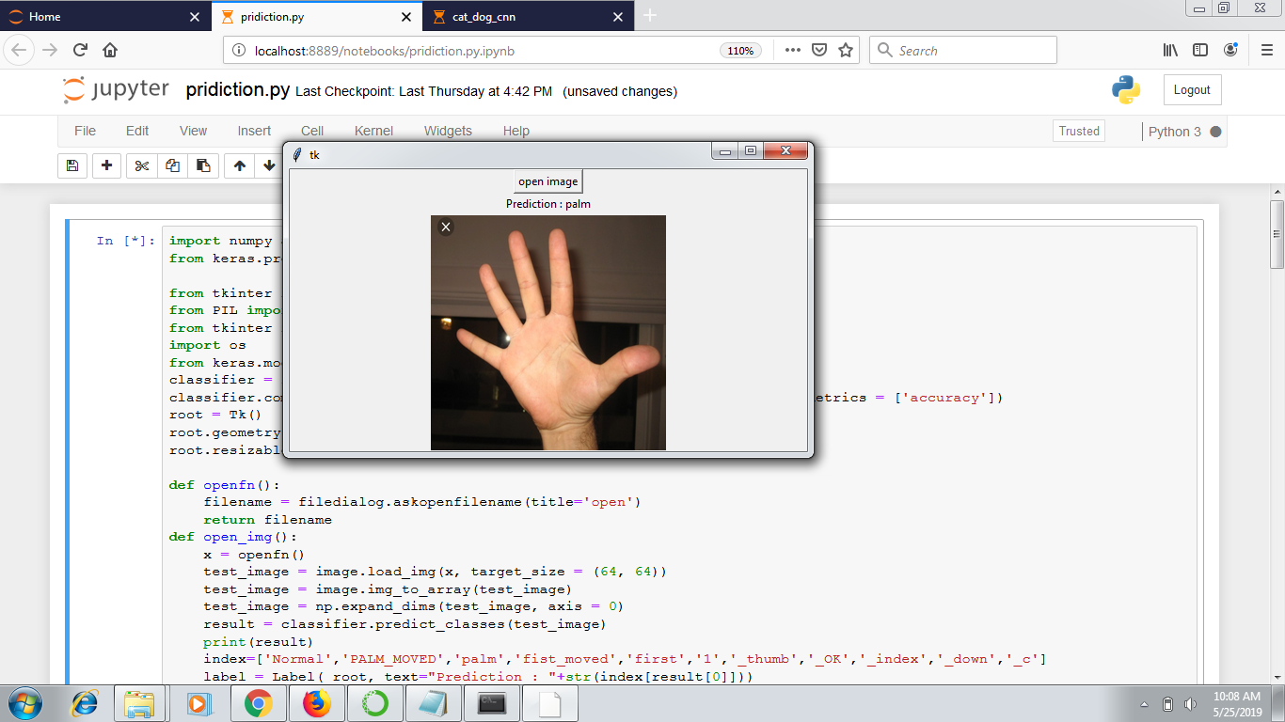

### Exploratory Data Analysis:

|  |  |  |
| --- | --- | --- |
| DATA DIVISION | NO.OF FOLDERS | NO.OF IMAGES |
| Test data | 10 | 400 |
| Train data | 10 | 1600 |
| Total no.of Images | - | 2000 |

### Data Modeling:

##### A Hidden Markov model can be used to recognize any temporal or modeling sequence.

* How? We can train a finite state machine using training data consisting of sequences of symbol s.
* States will represent, e.g., pose for gestures and transitions between states will have probabilities.

We used many functions to predict the output.

We used the CNN type to solve the situation

Also Softmax Activation Function, which divides the data according to the layers,

## Findings and Suggestions:

##### In order to send accurate nonverbal cues, you need to be aware of your emotions and how they influence you. You also need to be able to recognize the emotions of others and the true feelings behind the cues they are sending. This is where emotional awareness comes in.

##### Being emotionally aware enables you to:

##### Accurately read other people, including the emotions they’re feeling and the unspoken messages they’re sending.

##### Create trust in relationships by sending nonverbal signals that match up with your words.

##### Respond in ways that show others that you understand and care.

### Conclusion:

##### We have introduced gestures in this topic of language evolution by exploring the different types of gestures .In both infants and animals, gestures are a way of learning how to communicate. Infants imitate to match what they see to what they do, while animals imitate as a form of social learning – by imprinting behaviors from an adult or peer to a child.